FOCUS ON ENERGY® 2020 TRAINING SCHEDULE
February
February 11: | Air Sealing Done Right | Green Bay
February 13: | Air Sealing Done Right | Pewaukee
February 17–20: | Photovoltaic Series: 4-day series with MREA | Custer
February 25: | Energy Management & Technology: Fundamentals & Beyond | WI Dells
February 26: | Introduction to Motors, Fans & Pumps with Variable Frequency  Drive Opportunities | Middleton
March
March 3: | DLC Advanced Lighting Control System (ALCS) | Eau Claire
March 4: | DLC Advanced Lighting Control System (ALCS) | Green Bay
March 5: | DLC Advanced Lighting Control System (ALCS) | Pewaukee
March 12: | HVAC Applications for Commercial, Small Industrial, Schools &  Gov’t Facilities | WI Dells
March 12: | Operations and Maintenance for Energy Efficiency Practices | WI Dells
April
April 21: | Fundamentals of Compressed Air – Level 1 (changed to June webinar) | Appleton
April 22–23: | Advanced Management of Compressed Air Systems (2 day) (Late 2020) | Waupaca
May
May 7: | Energy Mgmt & Tech: Fundamentals & Beyond (Postponed to Sept.) | Green Bay
May 13–Aug 7: | Building Operator Certification (BOC) – Level 1 (June-Sept webinar) | Madison
June
June 22-25: | Fundamentals of Compressed Air – Level 1 webinar | Online
June 23-Sept 23: | Building Operator Certification (BOC) - Level 1 webinar | Online
July & August
 | No classes scheduled in July or August
September
Sept 15 – Dec 16: | Building Operator Certification (BOC) – Level 1 webinar | Online
September 9-10: | Energy Mgmt. & Technology: Fundamentals & Beyond webinar | Online
September 23-24: | Introduction to Motors, Fans & Pumps with Variable Frequency  Drive Opportunities webinar | Online
October
October 13-14: | HVAC Applications for Commercial, Small Industrial, Schools &  Gov’t Facilities webinar | Online
October 20: | Air Sealing Done Right: training available starting Oct. 20 | Online (self-paced)
October 27-28: | Operations and Maintenance for Energy Efficiency Practices webinar | Online
November
November 2: | PV System Operations & Maintenance: instructor-led discussion, prior to course beginning (approx. 30 mins) | Online
November 3-17: | PV System Operations & Maintenance: to be completed by Nov. 17 | Online (self-paced)
December
December 1-2: | Energy Mgmt. & Technology: Fundamentals & Beyond webinar | Online
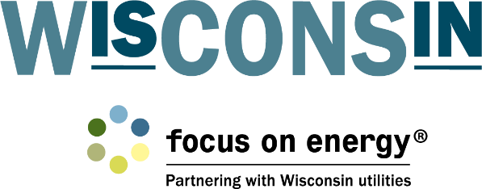
When dates & locations are confirmed, registration is opened
and courses are added to the Focus on Energy Training webpage. Visit www.focusonenergy.com/training for up-to-date information.

